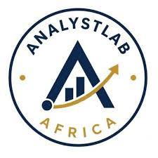

ANALYSTLAB AFRICA
Data Science Internship Programme

The first week of the data science internship at AnalystLab Africa has provided me with a valuable introduction to the practical workflow of a data science project. Before this assignment, I viewed data science mainly as building machine learning models. However, this project helped me understand that every successful data science solution begins with understanding the business problem and thoroughly exploring the data.
One of the key lessons I learned was the importance of business understanding. Researching employee attrition helped me appreciate how workforce challenges affect an organization's productivity, financial performance, and employee satisfaction. I also learned that data science is not only about developing predictive models but also about helping organizations make informed decisions through data-driven insights.
Working with the IBM HR Analytics dataset recandled my data exploration skills. I usd the Pandas library to inspect the dataset by examining its structure, data types, missing values, duplicate records, and descriptive statistics. This reinforced the importance of assessing data quality before performing any analysis or building machine learning models.
Another important learning experience was creating and interpreting data visualizations. Using bar charts, histograms, and boxplots helped me understand how different visualizations reveal patterns and relationships within the data. More importantly, I learned that creating charts alone is not enough; a data scientist must interpret the findings and explain their business implications in a way that stakeholders can understand.
During this project, I also encountered challenges. Initially, I found it difficult to interpret some of the visualizations and convert technical observations into meaningful business insights. Through additional research, practice, and guidance, I became more confident in explaining what the charts revealed and how the findings could support HR decision-making. This experience improved both my analytical thinking and communication skills.
Overall, this project has strengthened my understanding of the complete data analysis process, from understanding the business problem to communicating findings professionally. It has also highlighted the importance of combining technical skills with business knowledge to deliver valuable insights. As I continue this internship, I look forward to applying these skills to more advanced topics such as feature engineering, predictive modeling, and machine learning while continuing to improve my ability to solve real-world business problems through data science.

